CTM-I Use Case

Batch Load

Version 0.1

Use Case Name | Batch Load
Actor | Market Ops, Operations, App Support
Pre-conditions /Assumptions | User has Browser and is aware of the http path to the application.  User has successfully logged into the CTM-I application.  User has the right role to see the menu options.
Post Conditions | None
Screenshot | 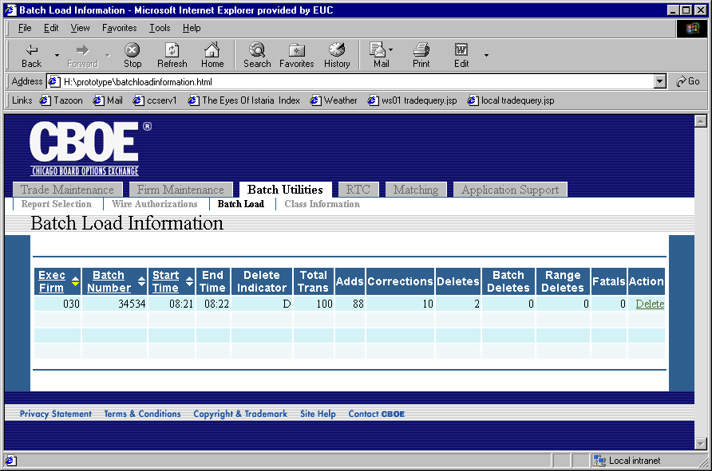
Flow of Events | - Actor selects “Batch Load” from the menu.  - Request the list of batch loads from CTM-R  - Batch Load screen appears with the data from CTM-R  - All Batch Loads show on the screen in a table format  - The table will display the following fields  - Executing Firm  - Batch Number  - Start Time  - End Time  - Delete Indicator  - Total Transactions  - Adds  - Corrections  - Deletes  - Batch Deletes  - Range Deletes  - Fatals  - The table can be sorted by Executing Firm, Batch Number, and Start Time.  - The table will contain a link to allow the user to delete a batch load  - When the link is clicked to delete a batch, the user will be prompted to enter a password.  - The delete request and password are sent to CTM-R for processing.  - The screen will refresh with the new list of batch loads.
Alternative Path | 5.2.1 If CTM-R returns an error, the error is displayed on the screen.

